**Week 02-01**

**Roll no:** 241801326

**Name:** Yogeetha A

**To calculate the height given in feet and in inches to centimetres.**



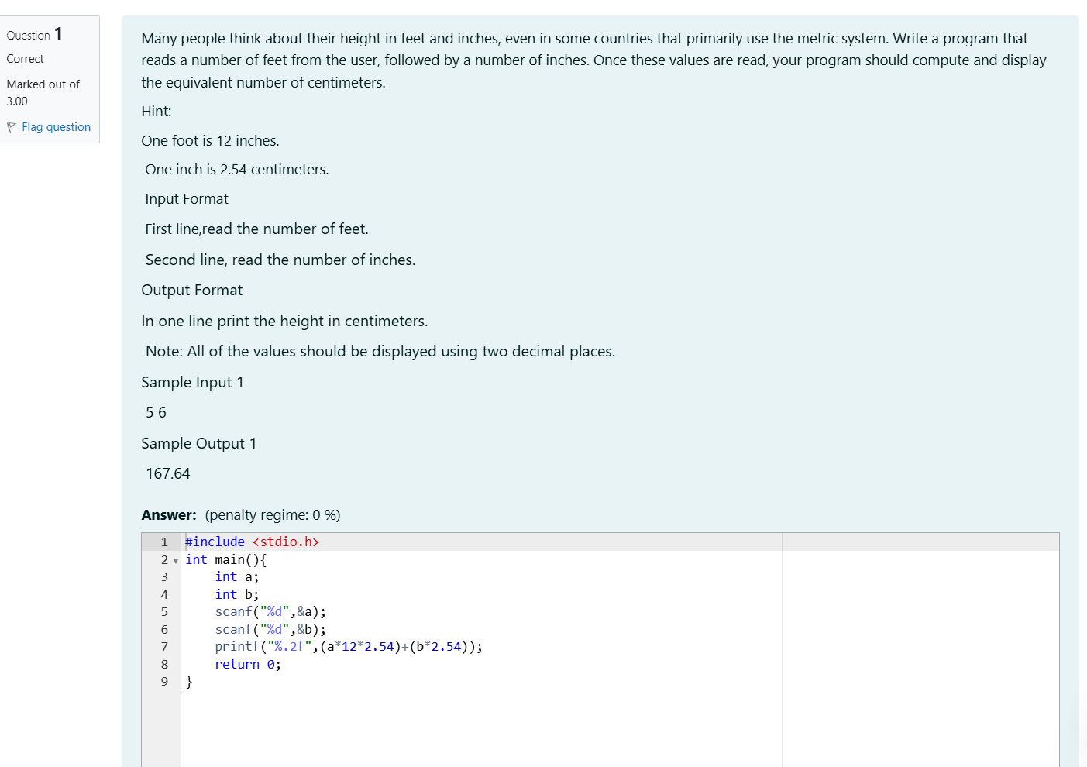

**OUTPUT:**

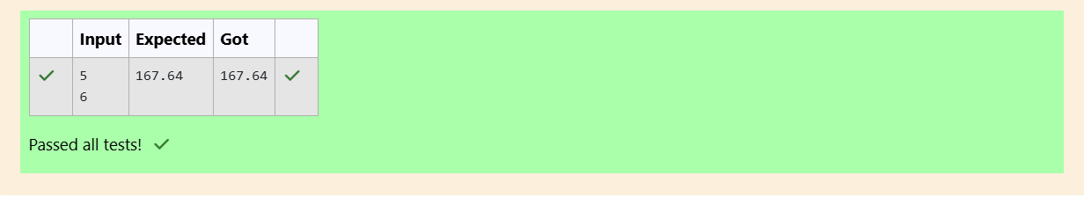

**Get two integers from the user and calculate the sum, difference, product, quotient and remainder of the numbers.**

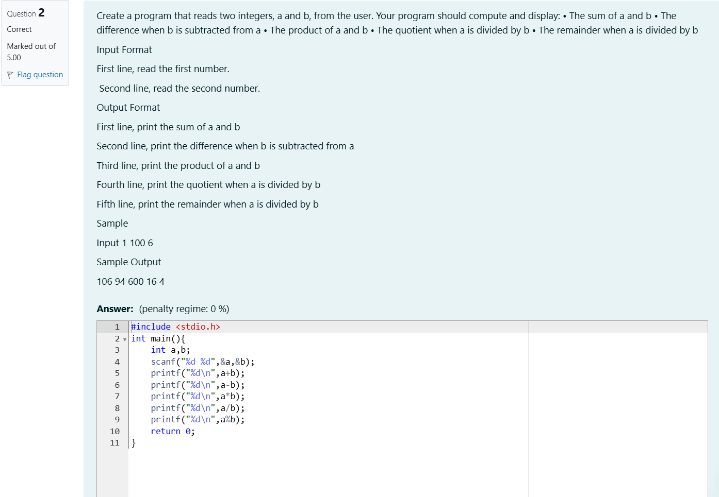

**OUTPUT:**

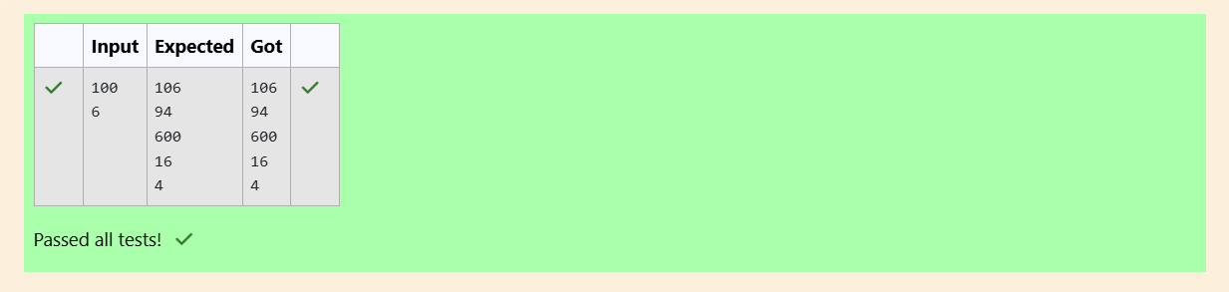

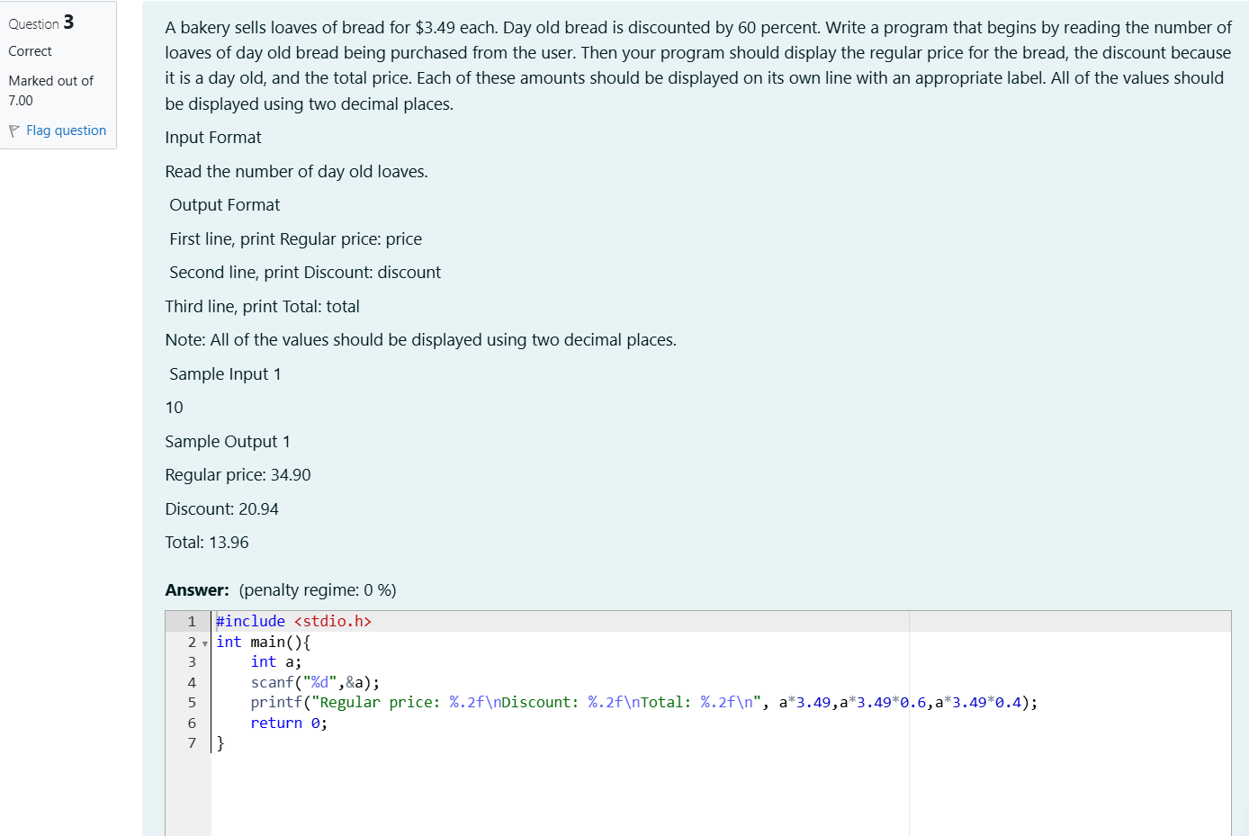

**OUTPUT:**

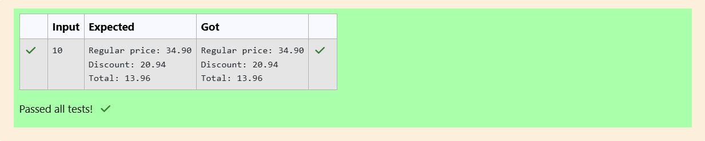



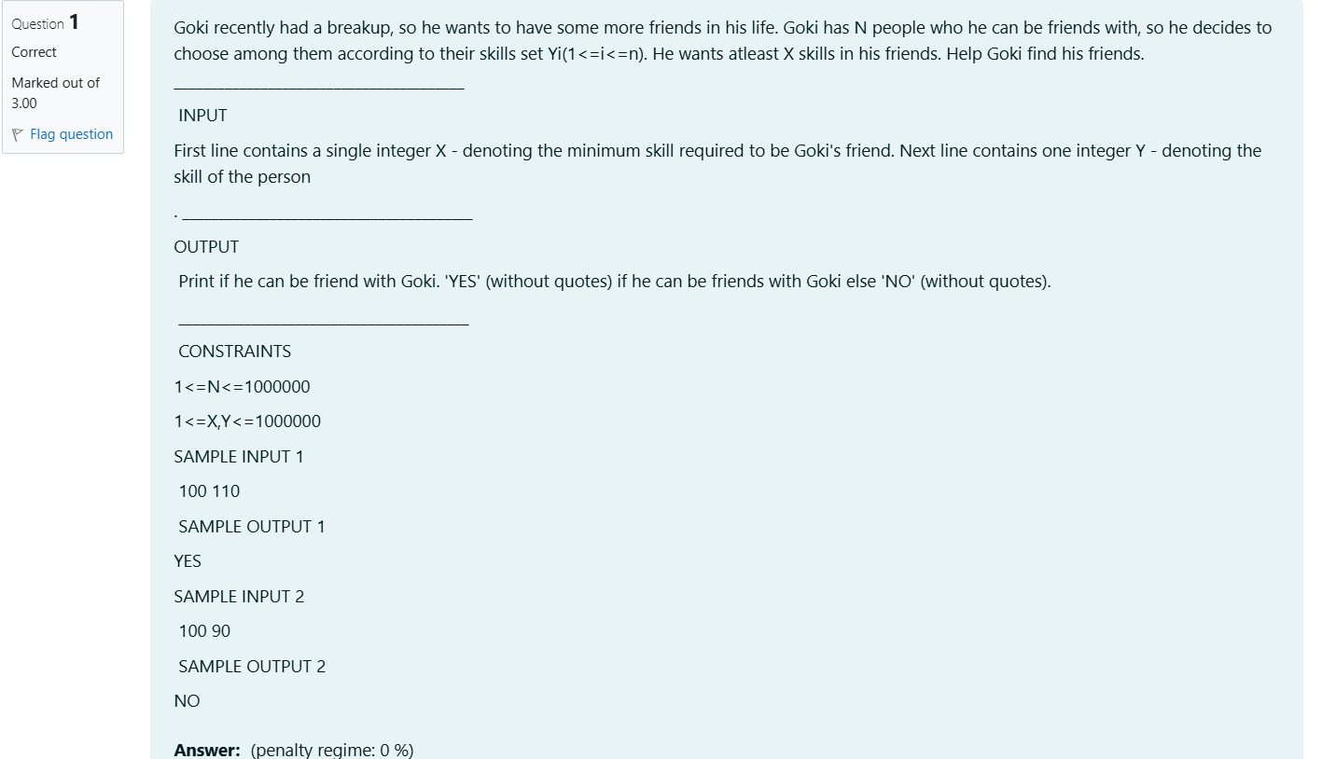

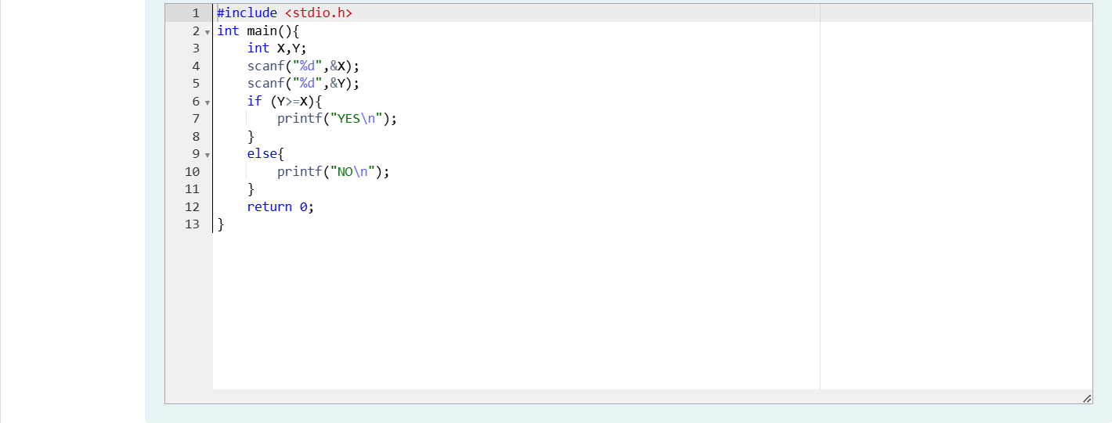

**OUTPUT:** 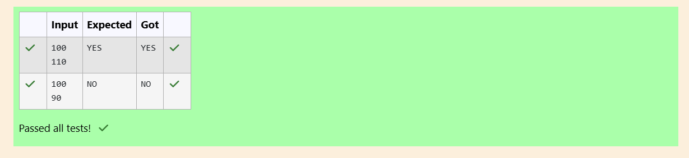

**To calculate the number of handshakes happened in a meeting room that everyone gets infected in that room.**

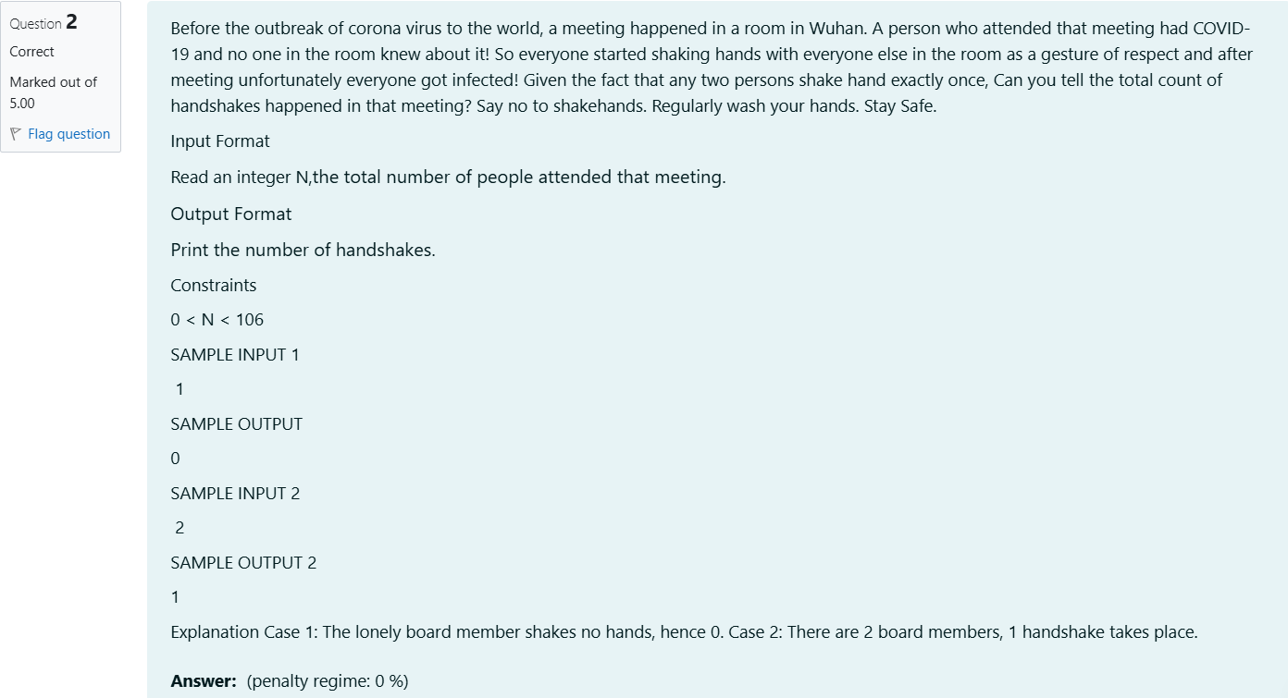

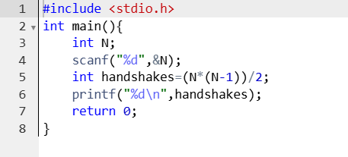

**OUTPUT:**

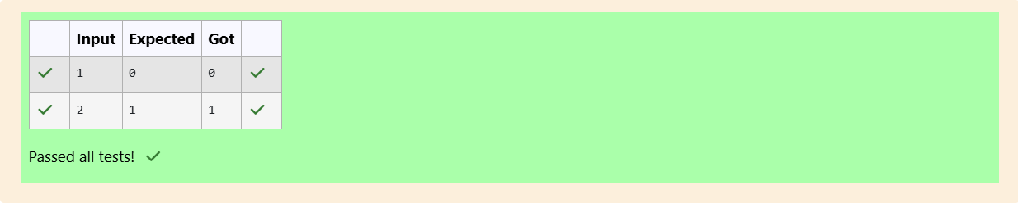

**To find the biggest number among three space separated integers.**

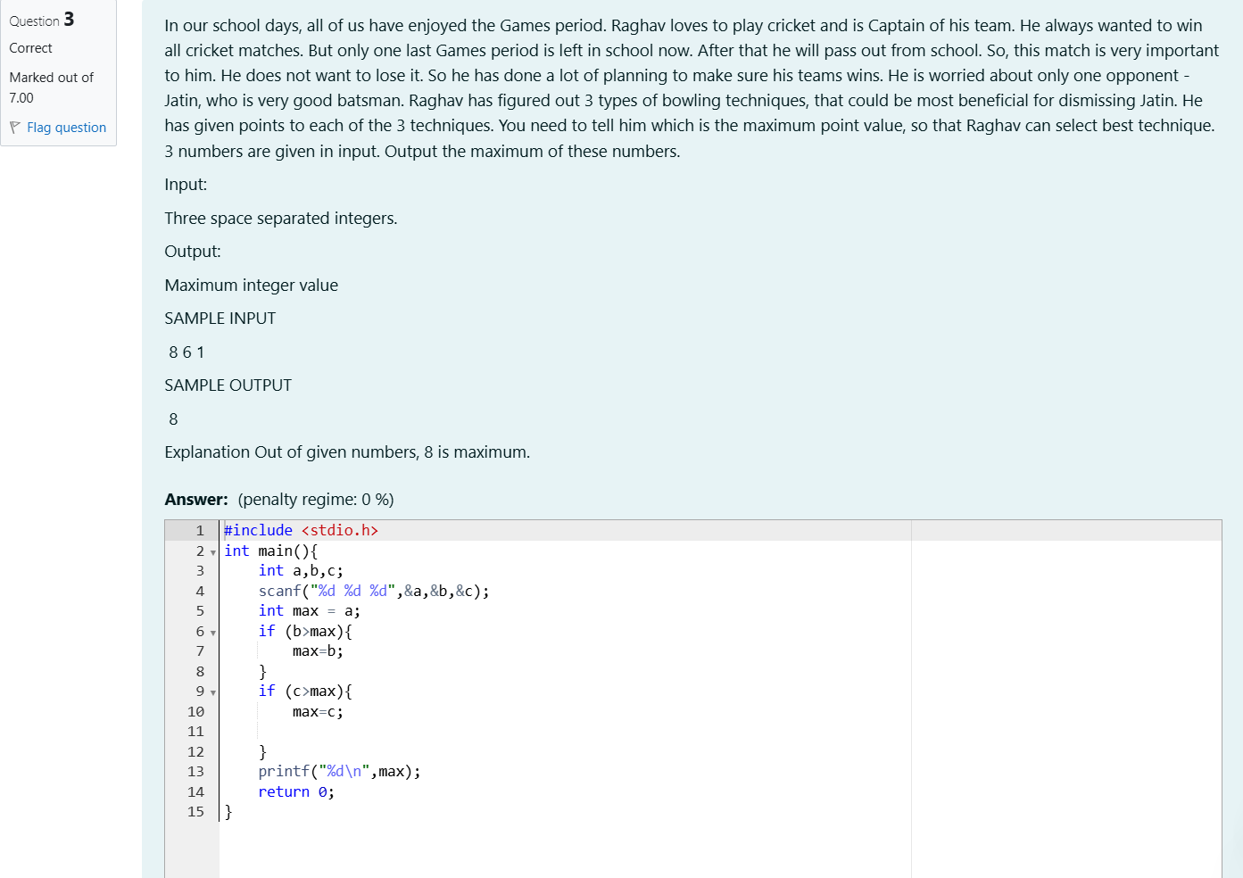

**OUTPUT:**

